Electronic, Structural, Transport and Optical Properties of Indium Oxide- A First Principle Study

Omprakash Verma¹, M R Meshram², A K Mishra³, B Keshav Rao⁴ and Mohan L Verma⁴
¹Department of Et &T, Bhilai Institute of Technology, Durg (C.G) India
²Department of Et &T, Govt Engineering College, Jagdalpur (C.G) India
³Department of EEE, Bhilai Institute of Technology, Durg (C.G) India
⁴Department of Applied Physics, FET-SSGI
Shri Shankaracharya Technical Campus, Junwani, Bhilai (C.G) India
E-mail: opvcit@gmail.com, meshram_66@gmail.com, anupmishra.bit123@gmail.com,
b.keshav26@gmail.com, cmprlssi@yahoo.com

Abstract
The density functional theory is approached for the study of structural, electronic and optical properties of an active material of Indium oxide (In₂O₃) which is used in a single layer organic light emitting diode. The structural analysis gives a small variation in the bond lengths of cubic, orthorhombic and in trigonal structures; there is p-p hybridization, it is stronger in the valance bands of all structures, density of states explains optical conducting metallic nature of cubic and orthorhombic structures and a semiconducting nature of trigonal structure. Charge density analysis explains a highly ionic and partial covalent bonds between In-O atoms, there is high optical reflection around 0 eV in all structures. There are broader optical absorption and optical conducting regions in cubic and orthorhombic structures, hence these are optically metallic conductors, and a semiconducting nature of trigonal structure.

Keywords: SIESTA; Density functional theory; Transmission curve; Optical properties

- Introduction
Recently, the science of thin films and its comparative technologies are playing a vital role in our daily life as they are found in number of applications from microelectronics to automobile parts [1]. These applications are highly depending on the physical properties of the materials chosen. The properties of thin films are highly influenced by the structure, properties of films and nature of the impurity added [2]. To meet the current need of the optoelectronic applications such as flat panel displays; photovoltaic cells; smart windows; light emitting diodes and optical wave guides; solar cell; touch panel controls; electromagnetic shielding of CRT used for video display terminals; the thin films should have high electrical conductivity and maximum optical transmittance in the visible region [3,4].
Indium oxide (In₂O₃) is potentially important in microelectronic device materials in solar cells [5]; flat-panel displays sensors [6]; transparent conductors [7]; and architectural glasses. The In₂O₃ is the best transparent conducting oxide (TCO) as it can be tailored as a conductor or semiconductor or even insulator. TCOs are the materials which exhibit unique properties such as low electrical resistivity (<10⁻³ ohm cm) either of conductors or of semiconductors, high optical transmittance in the visible region (>80%) and high infrared reflectance with a wide band gap [8,9]. The efficiency and performance depends on their electrical and optical properties. Despite the vast and quickly growing number of applications of TCOs, their electronic structures still poses a number of fundamental open questions, among them the size and character of the band gap [10]; details of the band structure [11]; and the possible existence of a charge accumulation layer on the surface; as observed on films of In₂O₃ [12].
The electrical conductivity of the TCO films can be increased by increasing either carrier concentration or mobility of the carriers [13]. Carrier concentration has a diverse influence on the optical property of the TCO films due to the plasma resonance [14]. Since the mobility is directly proportional to repose time and inversely proportional to the effective mass of the carriers, the mobility of the charge carriers can be enhanced either by increasing response time due to fewer defects or by reducing the effective mass of the carriers.
The new OLED technologies involve a thin organo-metallic layer in a sandwich structure between electrodes [15-17]. Phosphorescence of organo-metallic compound is generally given by a single color, but using of a double-emission layer can give two colors [18]. To obtain different colors from the same thin layer, mixtures of organo-metallic compounds with specific phosphorescence are necessary [19]. The density functional theory is approached for further investigation of the study of structural, electronic and optical properties of an active material Indium oxide (In₂O₃) which is used in a single layer organic light emitting diode.

- Methodology
The Local density approximation (LDA) is considered in the scheme of Ceperly and Alder (CP) to describe the exchange and correlation potential functional [20]. The ground state configurations are determined by a computational program SIESTA, it is an acronym of a code Spanish Initiative for Electronic Simulations with Thousand of Atoms, where a numerical atomic basis approximation is implemented [21,22]. In simulation, double zeta plus polarization (DZP) basis sets are used [20]. The core electrons were treated by norm-conserving pseudo potentials [23], the pseudo potentials and the basis sets for I and O are taken from SIESTA code [24]. The atomic configurations are: I: [Kr] 4d¹⁰5s²5p¹ and O: [He] 2s² 2p⁴, where core configurations are shown in parenthesis. In₂O₃ has three configurations, cubic, orthorhombic and trigonal, all are considered for simulation. In cubic structure, a lattice of size (20.47,19.32,16.79), with k-points (4,1,1) and a mesh cut-off 450 Ry are obtained as outcomes of their respective optimizations, for orthorhombic structure; these values are (7.36,13.57,29.76), (6,1,1) and 350 Ry, and for trigonal structure; these are (14.72,12.25,11.50), (7,1,1) and 400 Ry, respectively. Finally, all structures are optimized with their optimized values of lattice constants, k-points and cut-off until the required forces on each atom to be smaller than 0.005 eV/Å.

- Results and Discussion
Equilibrium configurations of cubic, orthorhombic and trigonal structures are shown in Fig. 1a,b & c, their space groups are: Ia3(206), Pnma(62), R3c(167) respectively. Bond lengths between atoms are: In cubic: In-O 2.25 Å, O-O 3.58 Å, In-In 3.63 Å, In orthorhombic: In-O 2.57 Å, O-O 3.05 Å, In-In 3.67 Å, and in trigonal: In-O 2.59 Å, O-O 1.42 Å, In-In 3.66 Å. We can observe,

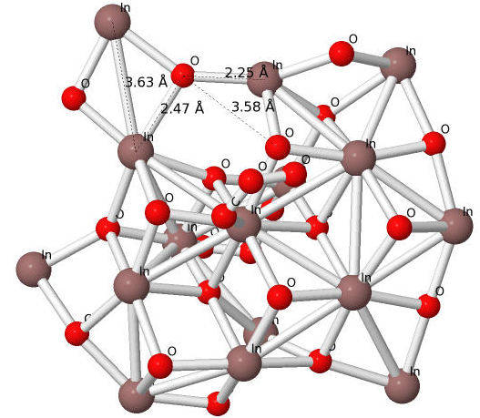

(a)

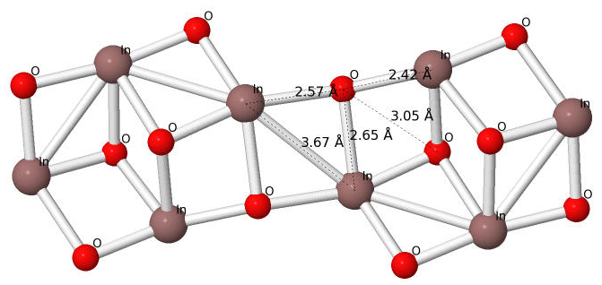
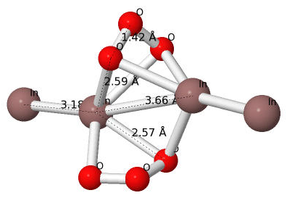

(b) (c)
Fig. 1 Equilibrium configurations of: (a) Cubic, (b) Ortho-rhombic and (c) Trigonal In₂O₃

there is little variation in bond length of In-O and In-In atoms, and big difference in O-O bond lengths. The size of structures gradually reduces due to total number of atoms gradually reduces from cubic : 40, orthorhombic : 20 to trigonal : 10.
In the projected density of states of cubic structure, O eV represents the Fermi energy level, below levels are of valance band and above are of conduction band. In the valance band; higher peaks of 2p orbital states of O are obtained, and lower peaks of 5p orbital electronic states of In atoms, vice versa is observe in conduction band, it can be seen in Fig. 2a. Similar kind of distribution of orbital states observed in orthorhombic structure, except a small forbidden gap at higher levels of conduction band, it is shown in Fig. 2b. A little different distribution is observed in a trigonal structure except orbital distribution, two forbidden energy gaps are found, one is in the valance band and second is in conduction band, it is shown in Fig. 2c, there is p-p orbital hybridization in all structures. Comparison of density of state of three structures is shown in
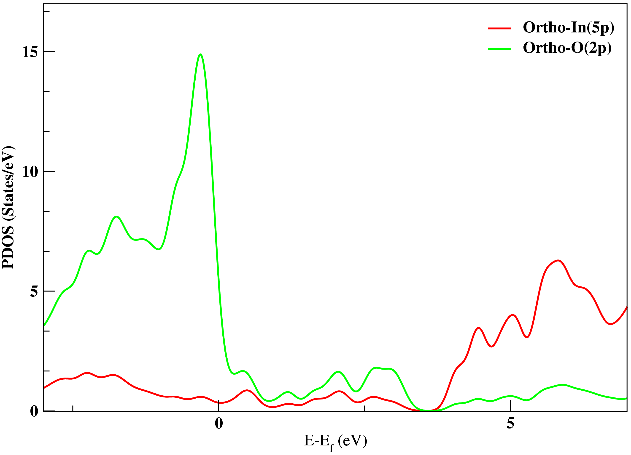
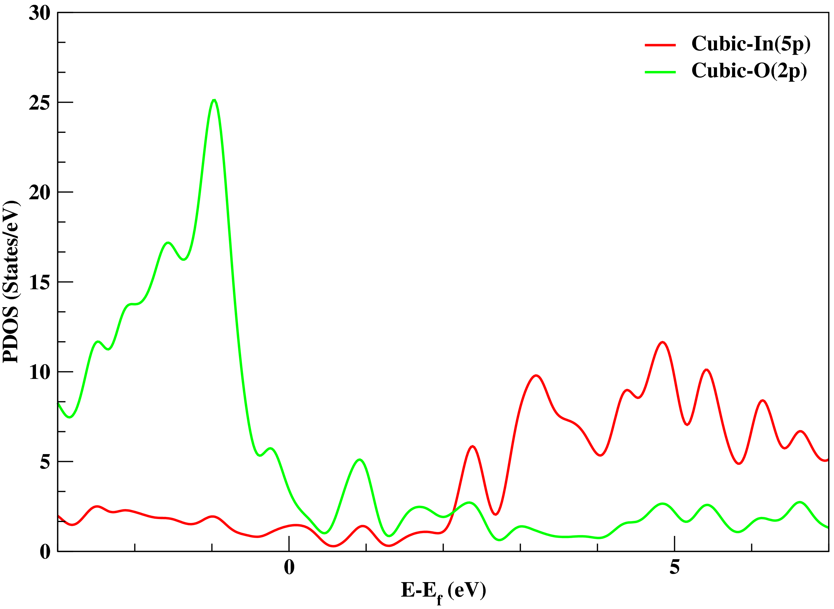

- (b)
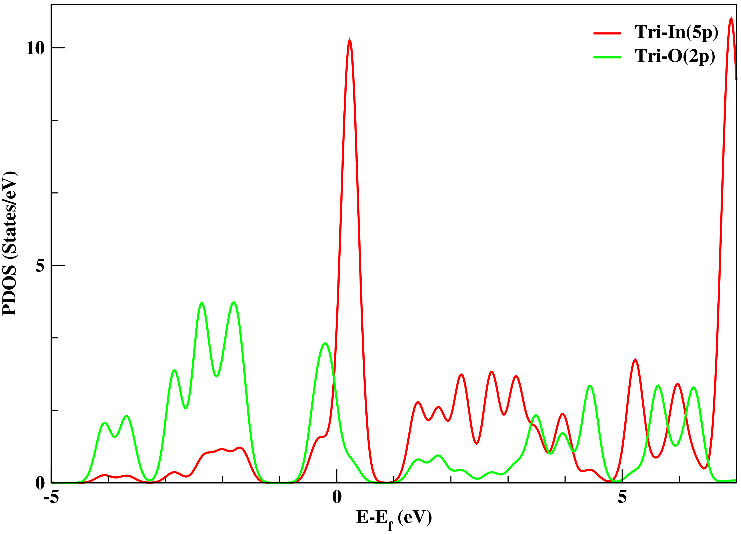
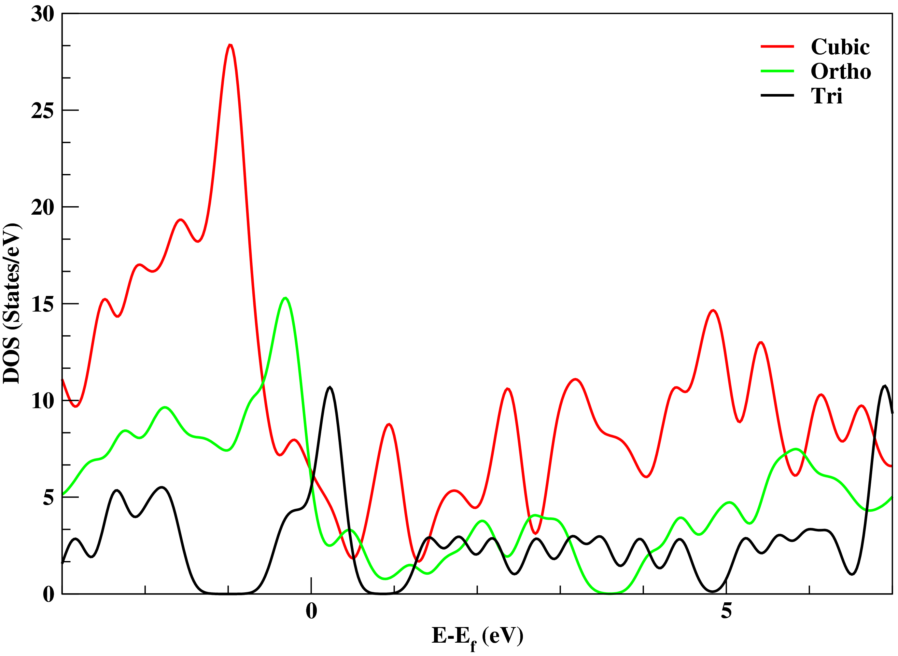

(c) (d)
Fig. 2 Projected density of states of In₂O₃: (a) Cubic, (b) Ortho-rhombic, (c) Trigonal, and (d) Comparison
of density of states.

Fig. 2d, cubic and orthorhombic structures exhibit zero forbidden energy gaps, i.e. these structures are conductors. In trigonal structure two forbidden energy gaps are found nearby Fermi level, lower band width is around 1.0 eV and upper band width is around 0.5 eV, i.e. it exhibits a semiconducting nature.
To observe the nature of bonds found between indium and oxygen atoms in all structures, charge density distributions are analyzed which are shown in Fig. 3a, b & c respectively, Fig. 3d shows color codes of charge density. In all structures there is highly ionic and partially covalent bonds, concentric circles around oxygen atoms representing ionic nature and little distorted

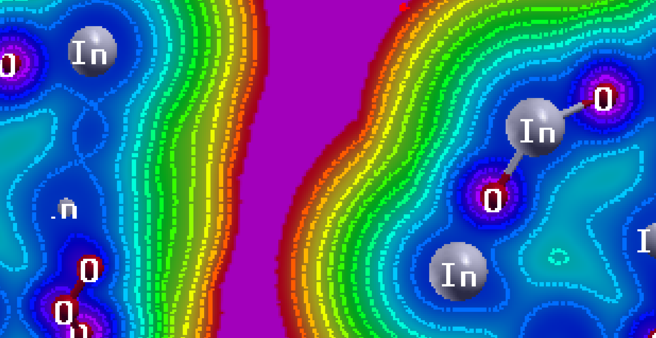
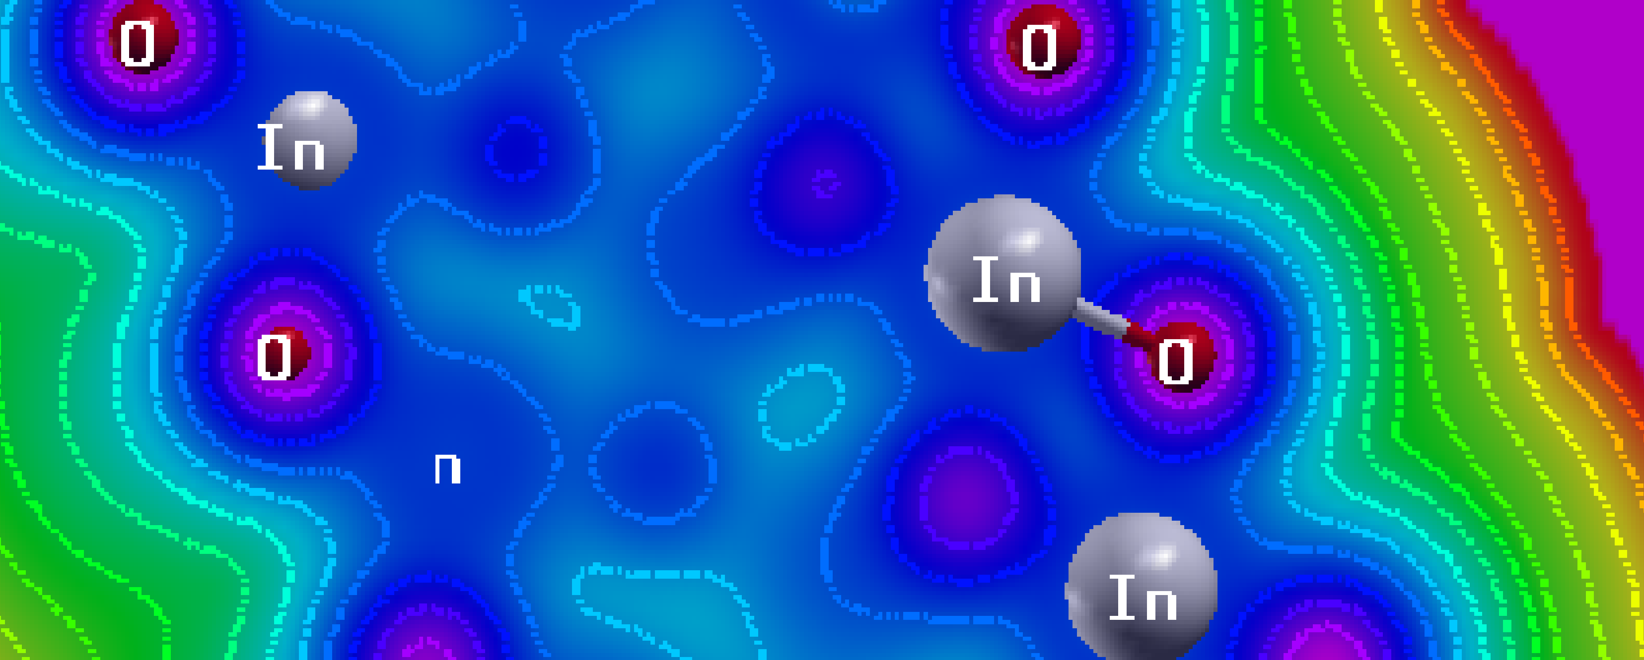

(a) (b)
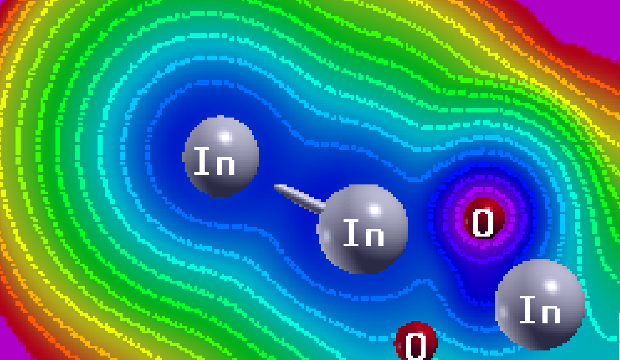
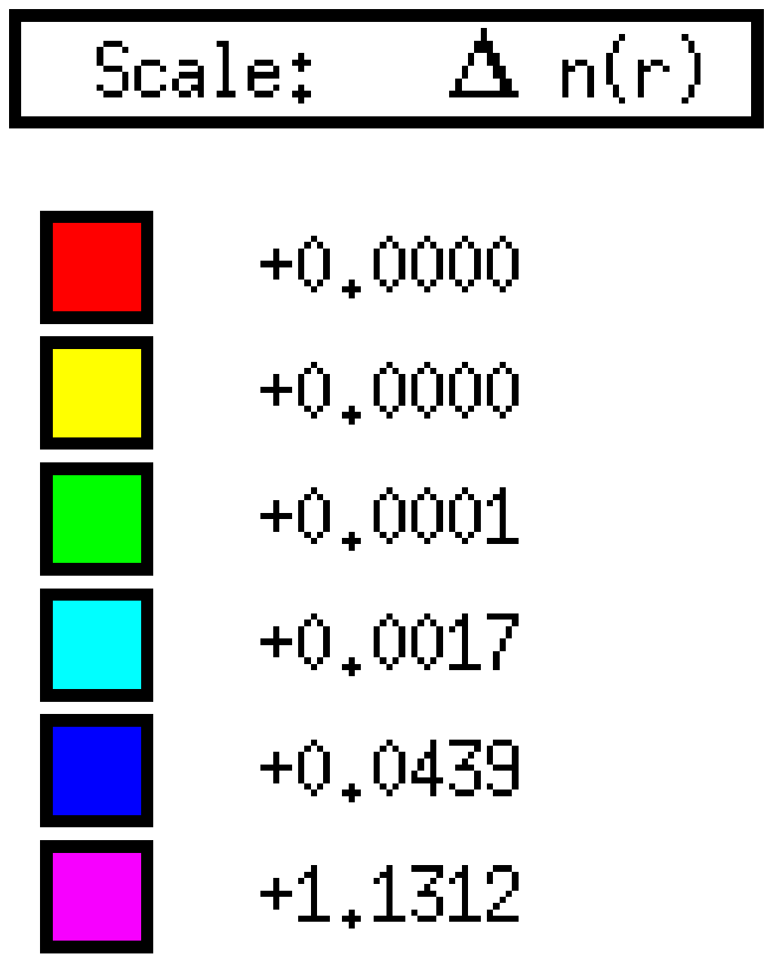

(c) (d)
Fig. 3 Charge density distribution of: (a) Cubic, (b) Ortho-rhombic, (c) Trigonal In₂O₃, and (d) Color codes

dumb-bell shaped curve between In and O atoms shows a less intense covalent bond, it is obtained due to overlapping of wave functions of atomic valance shells. There is covalent bond between In-In atoms.
Figs. 4a & b are representing real and imaginary parts of dielectric constants, a complex dielectric function which is the sum of the real and imaginary parts; expressed by:
… (1)
where, be the frequency of light. There are high peaks at 0 eV and very small peaks in the higher energy ranges of cubic and trigonal structures, in ortho structure no peaks at 0 eV. In imaginary part, few peaks are found around 3 & 5 eV almost in all structures, after 10 eV all curves becoming flat and zero. The values of are very significant in finding of the reflectivity, refractive index and the absorption coefficient, these are expressed by [25]:
… (2)
… (3)
and … (4)

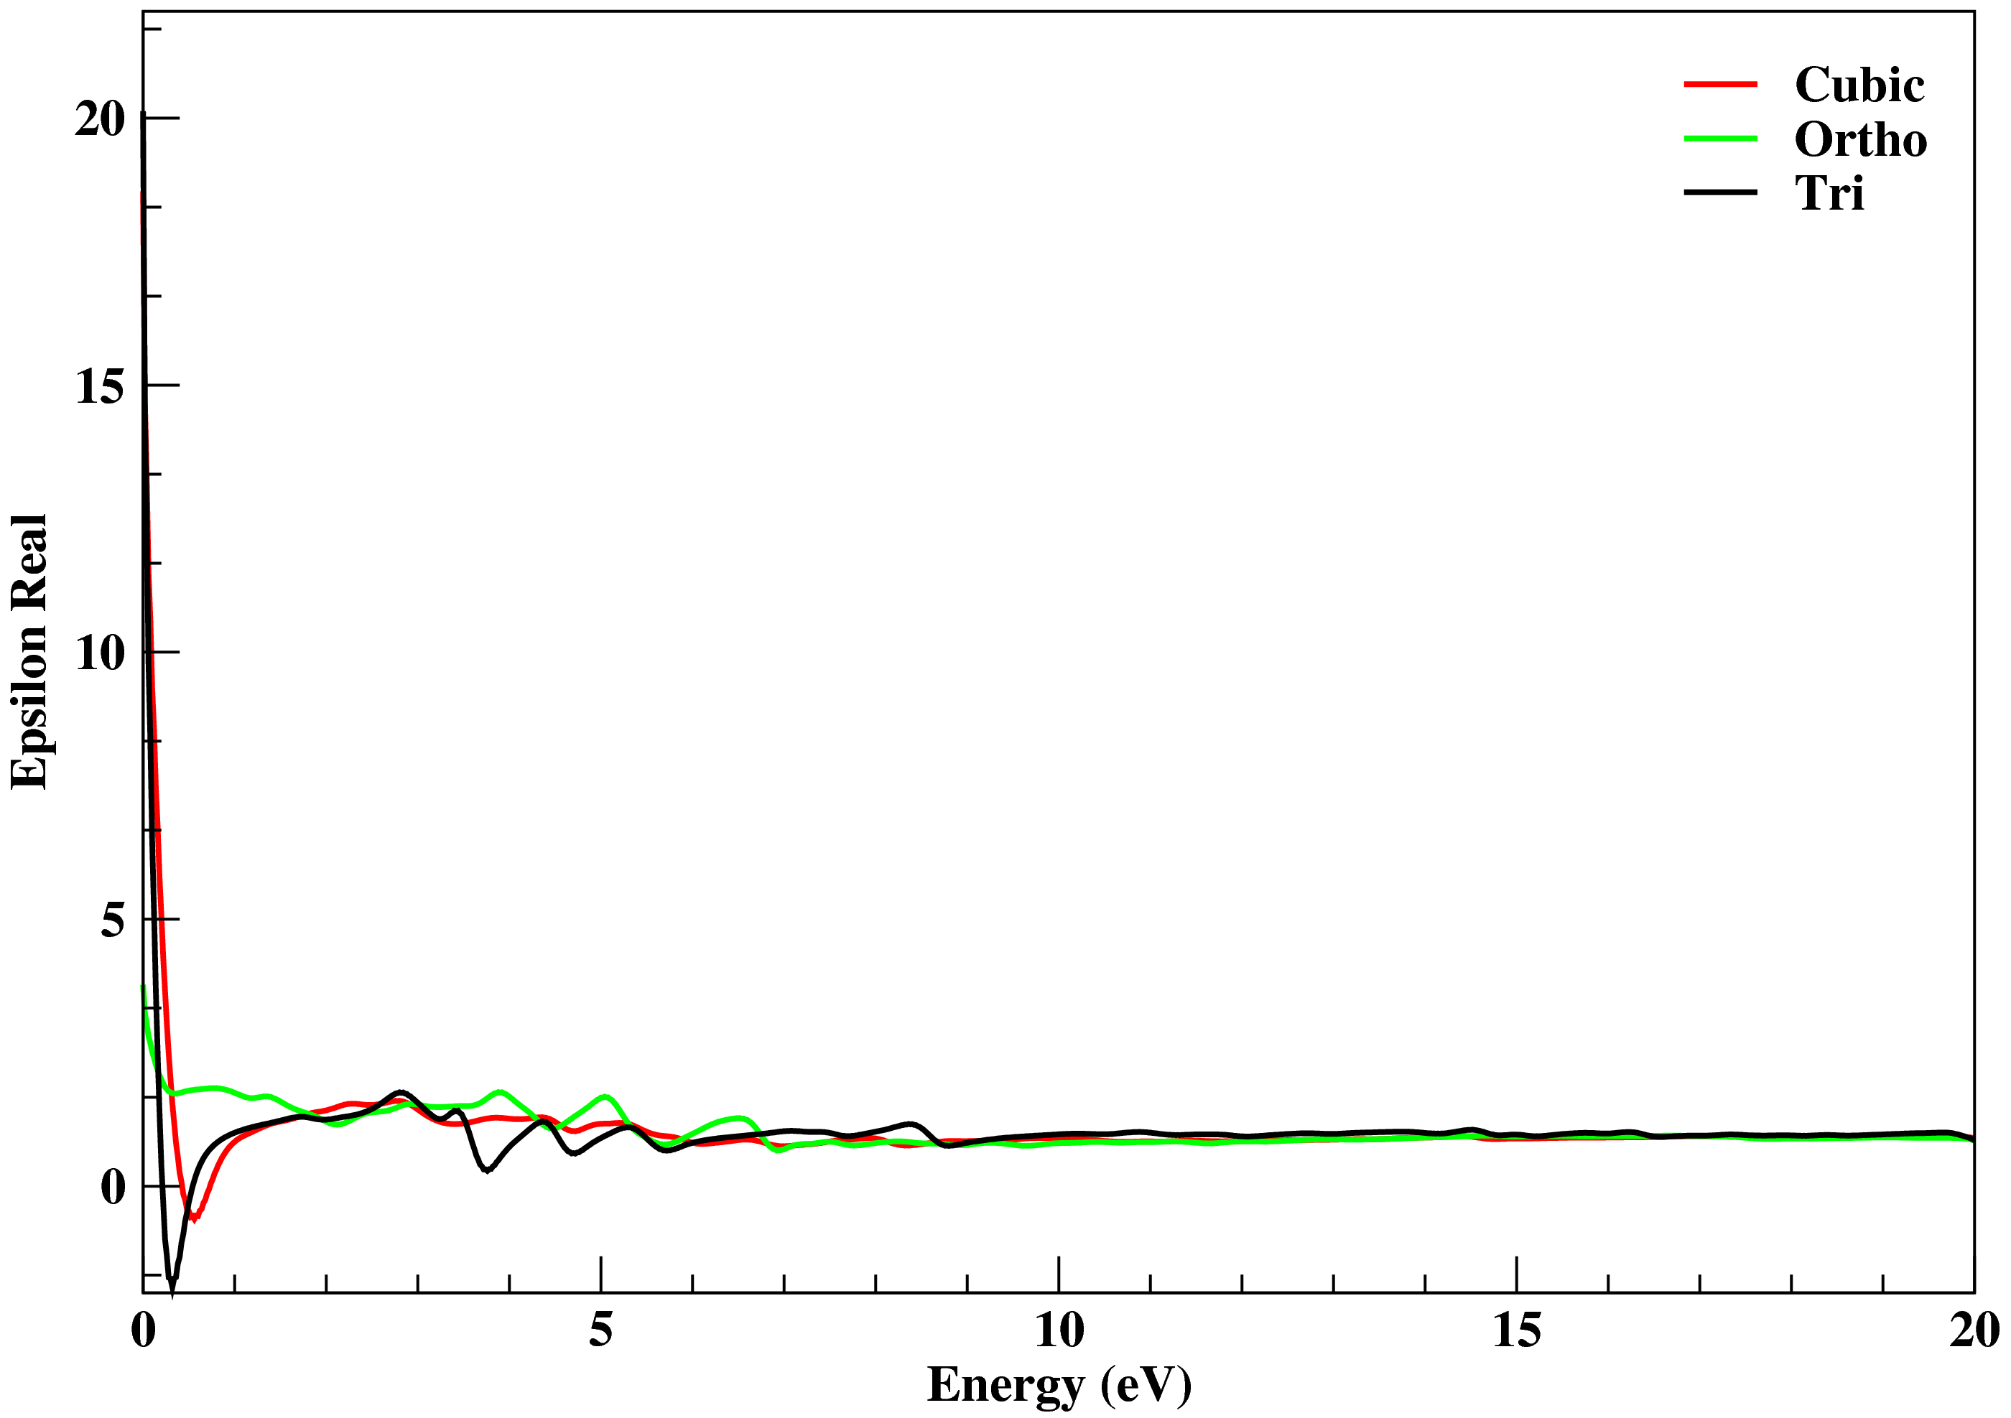
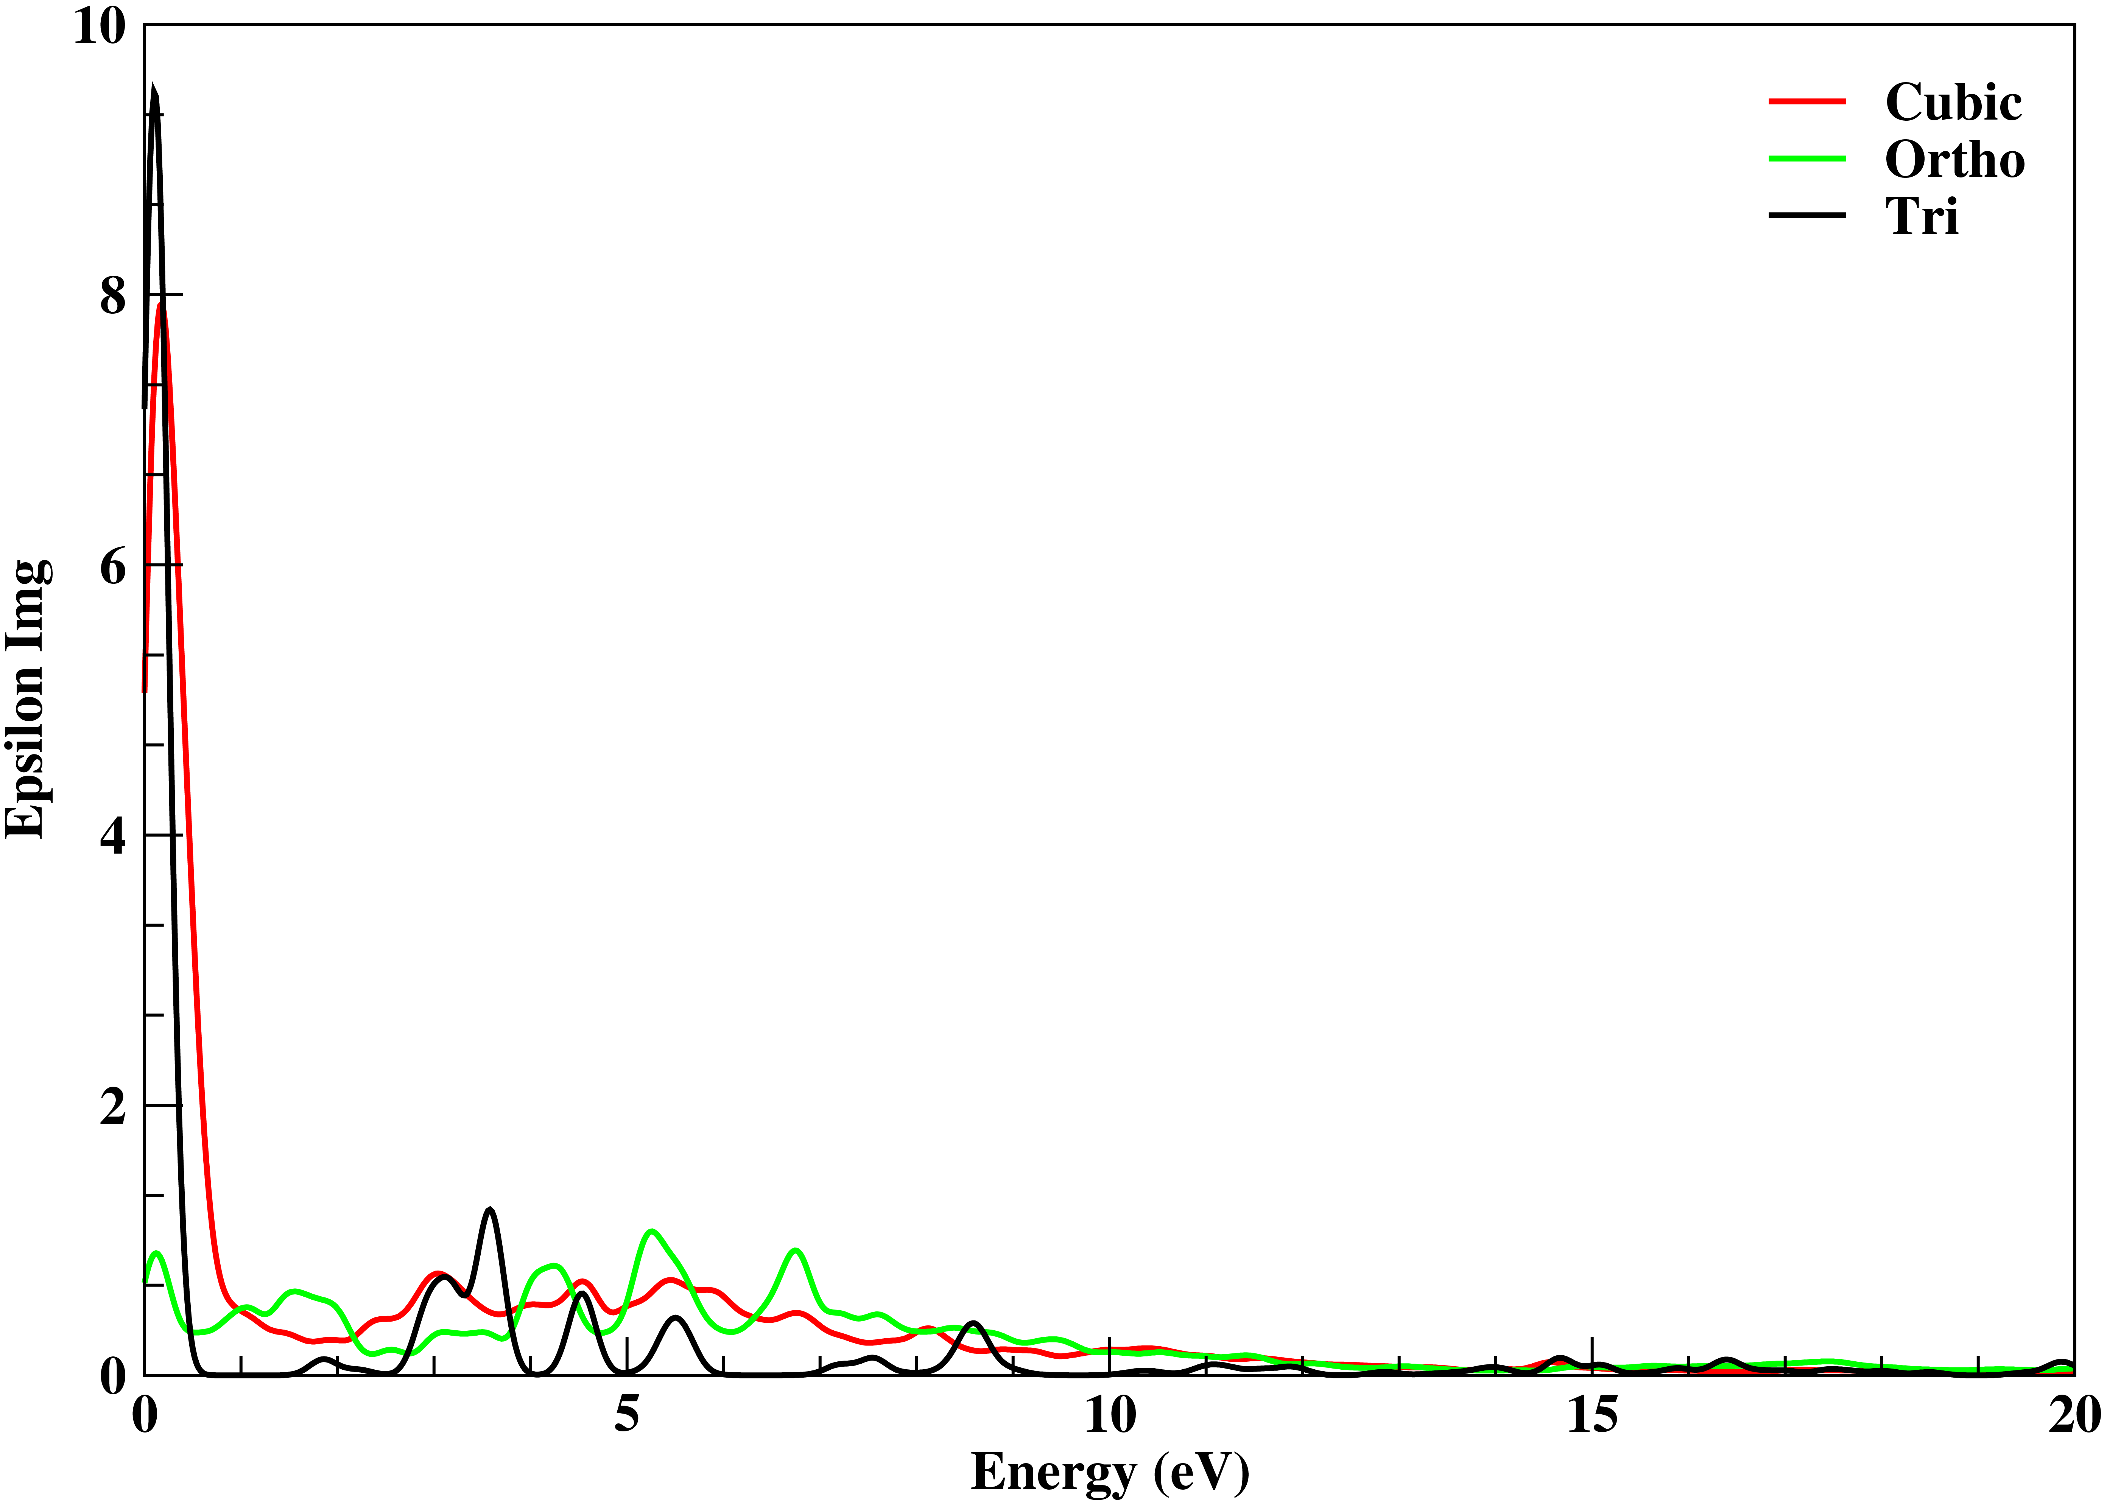

- (b)
Fig. 4 Dielectric constants: (a) Real, (b) Imaginary parts of all three structures of In₂O₃

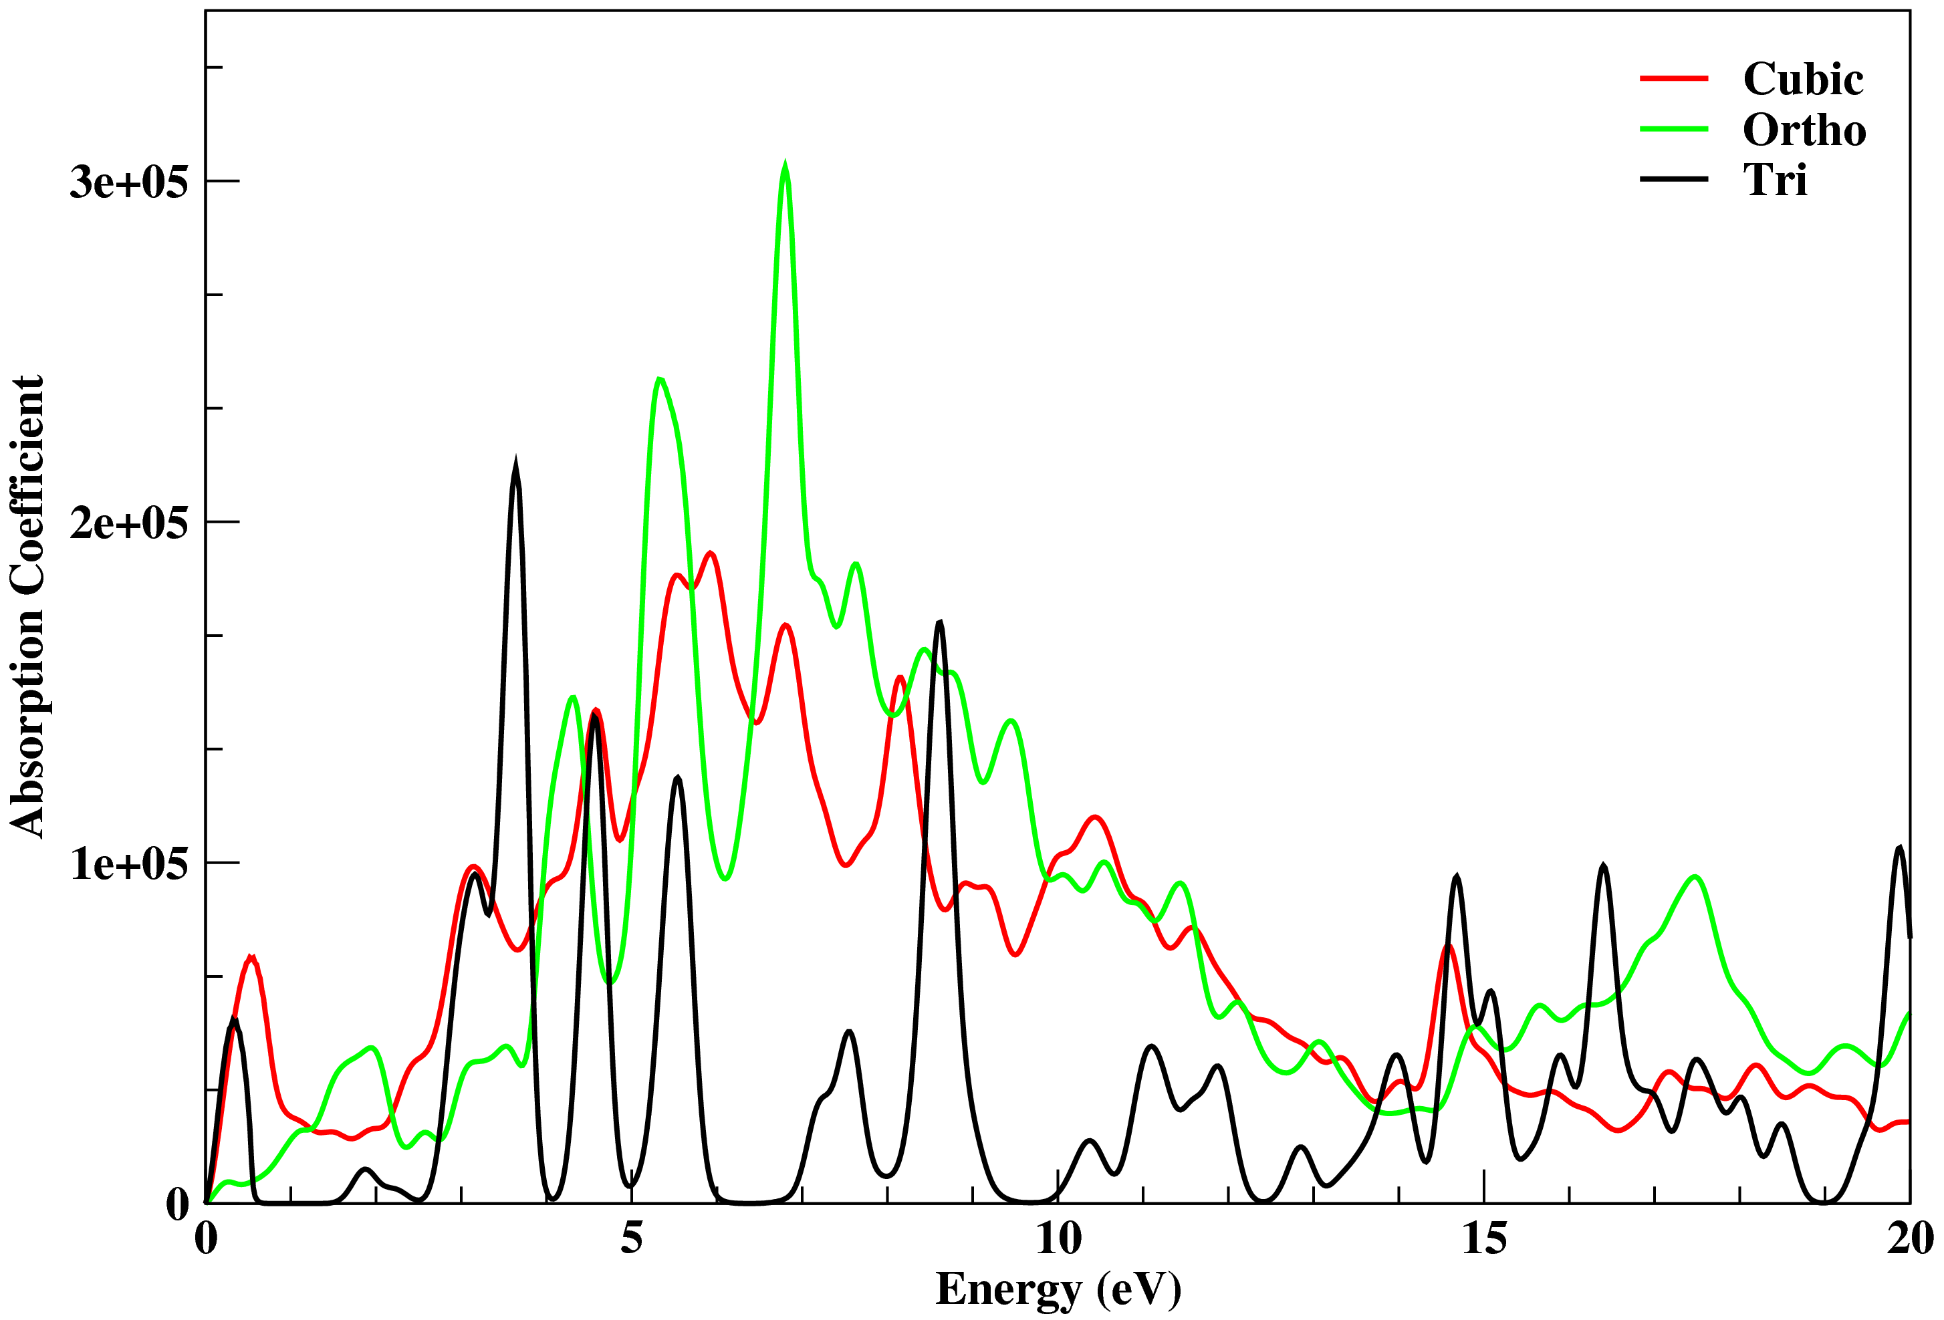
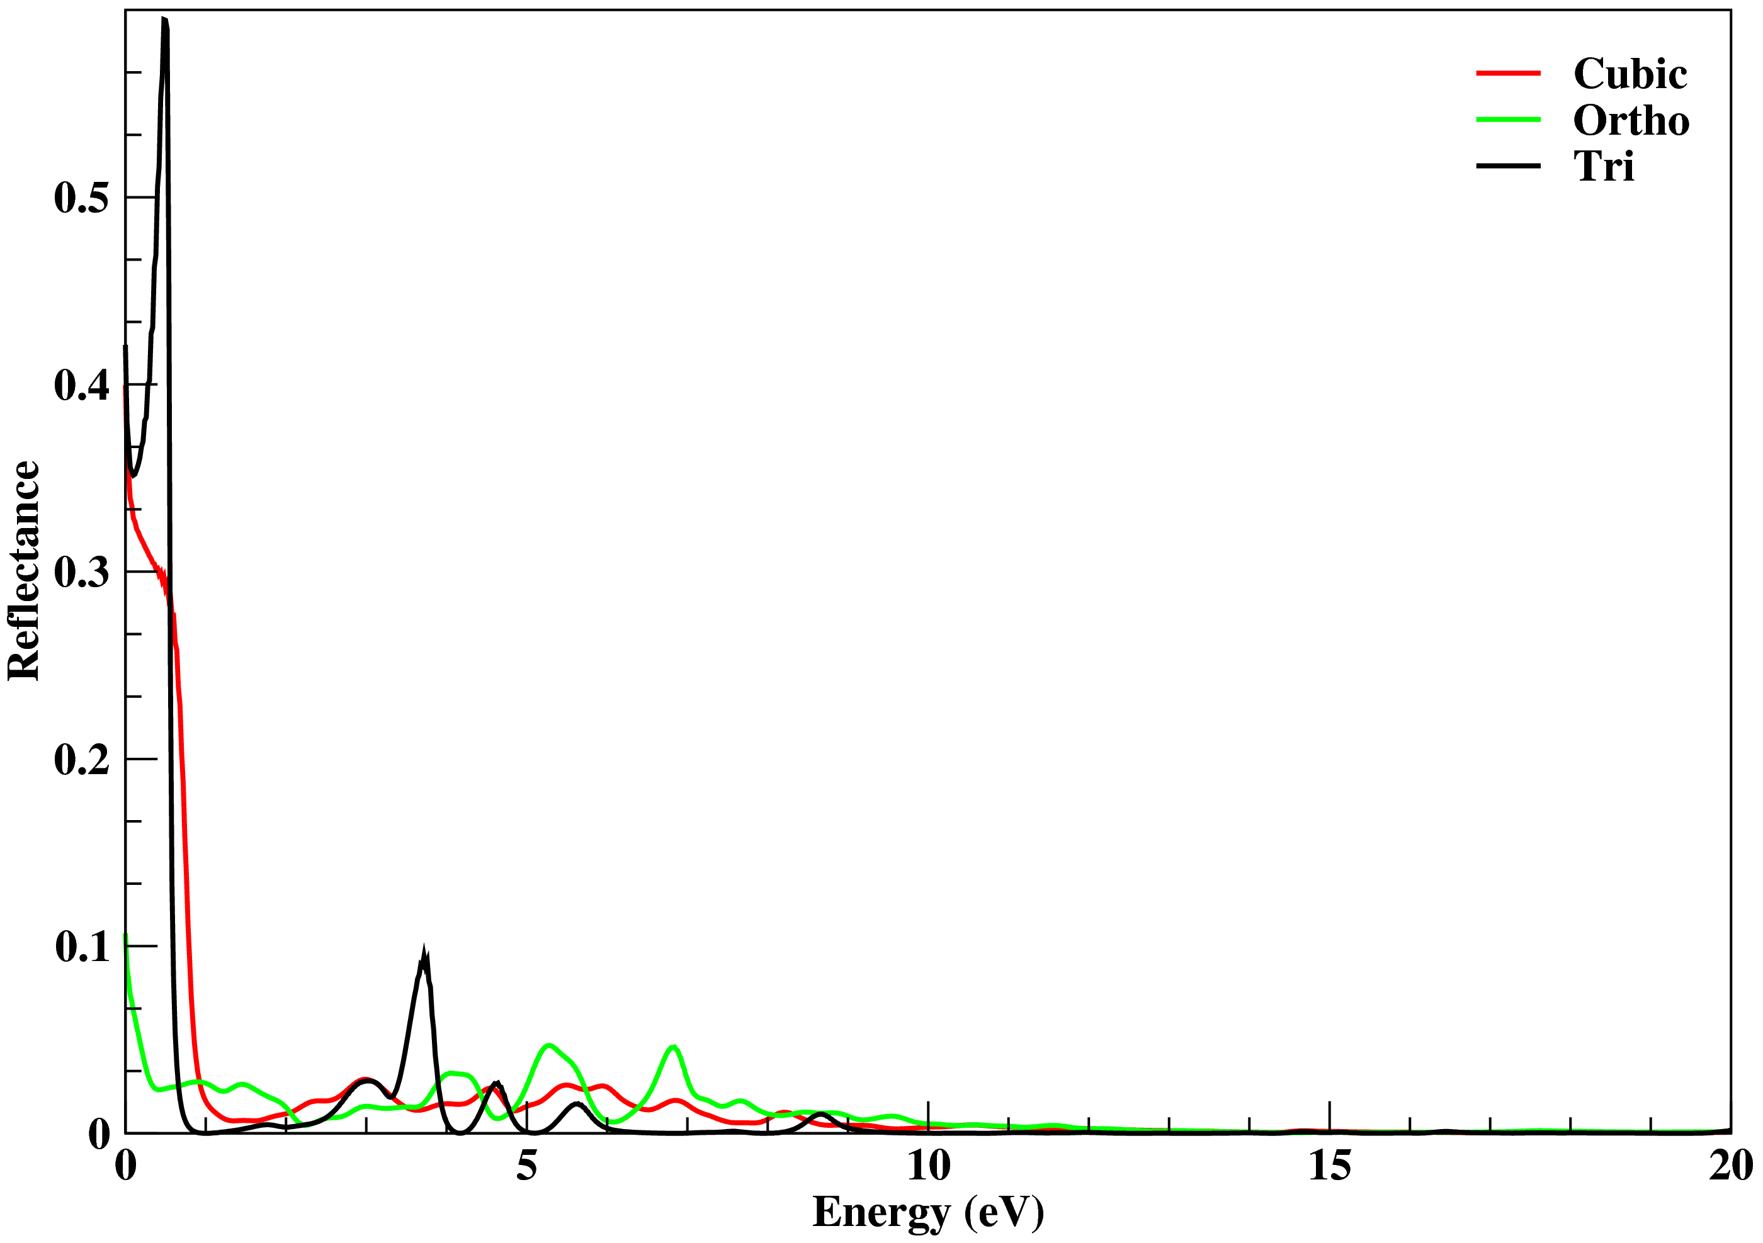
Reflectance curves (Fig. 5a) are similar as curves of imaginary dielectric constants, it gives the energy ranges which don’t allow light to transmit. There are broader absorption bands in cubic and orthorhombic structures in the energy range of 0.5 eV to 20 eV, high absorption peaks are at 7 eV and 5.5 eV of ortho structure and at 6 eV and 7 eV of cubic structure. In trigonal structure, there are high absorption peaks at 3.5 eV, 8.6 eV, 4.5 eV and at 5.5 eV, a broader absorption band is found in the energy range of 13.5 eV to 18.5 eV, it is shown in Fig. 5b. There is nil absorption at 0 eV in all the structures.

- (b)
Fig. 5 (a) Reflectance, (b) Absorption coefficient of cubic; orthorhombic and trigonal structures of In₂O₃

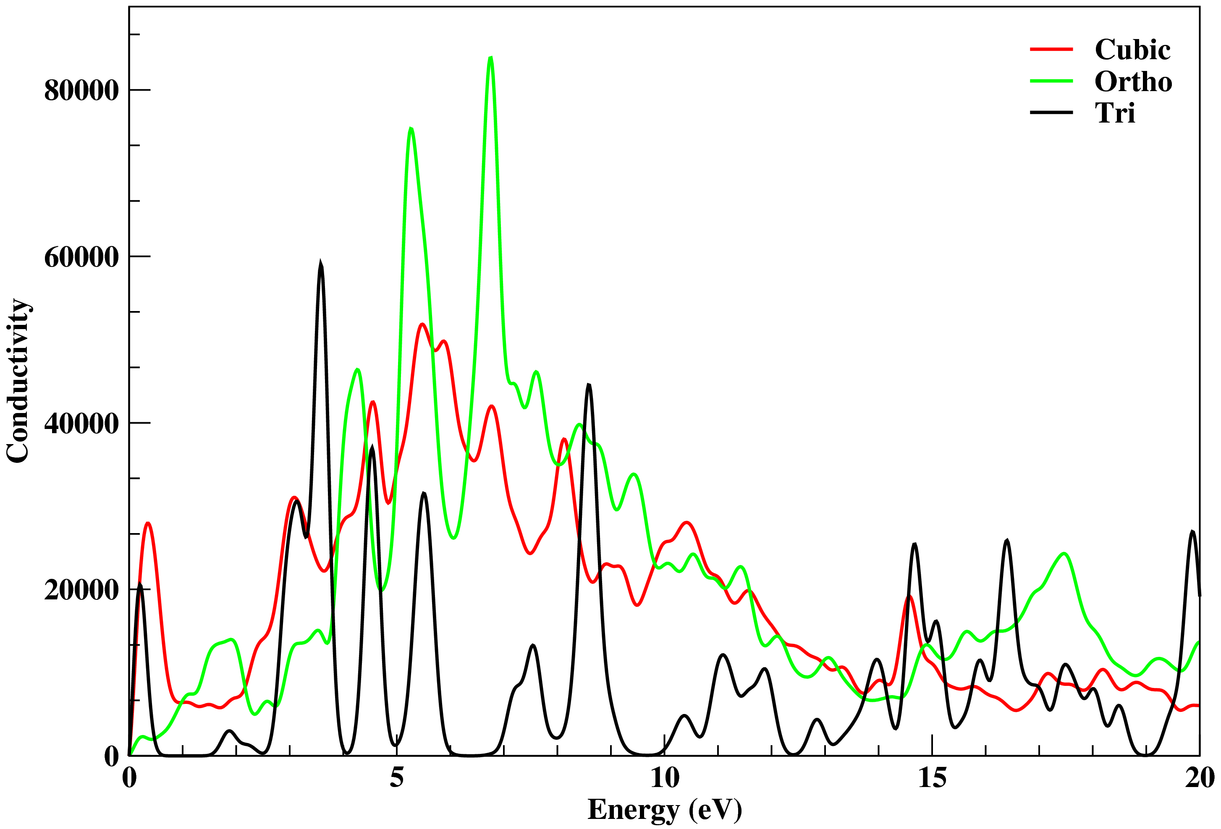

Fig. 6. Optical conductivity of cubic, orthorhombic and trigonal structures of In₂O₃

The optical conductivity of all structures is shown in Fig. 6, it is quite similar to the absorption profile, cubic and orthorhombic structures reveal the optical conducting metallic nature, there are highly optical conducting peaks at 7 eV in ortho, at 5.5 eV in cubic structures. Trigonal structure is showing a semiconducting nature, it has high optical conducting peak at 3.5 eV, its conducting region is in the range of 13.5 eV to 18.5 eV. Finally, cubic and orthorhombic structures justify the application of In₂O₃ an active material of organic light emitting diodes.

- Conclusions
There is small variation in bond lengths of In-O and In-In atoms, and a big difference in O-O bond lengths of cubic, orthorhombic and trigonal structures of In₂O₃. Projected density of states explains a strong p-p hybridization in all structures; it is stronger in the valance band region. Density of states reveal a metallic nature of cubic/ortho structures and a semi-conducting nature of trigonal structure. The charge density exhibits a highly ionic and partial covalent bond of In-O atoms, covalent bonds of In-In atoms in all structures, and there is high reflectance at around 0 eV.
There are broader optical absorption and optical conducting regions in cubic and orthorhombic structures in the range of 0.5 eV to 20 eV, hence these are optical metallic conductors, there is high conducting peak at 7 eV in ortho and at 5.5 eV in cubic structures. Trigonal structure exhibits a semi-conducting nature, there is a optical absorption/conduction in the energy range of 13.5 eV to 18.5 eV, it has high optical conducting peak at 3.5 eV. Cubic and orthorhombic structures justify In₂O₃ to be used as an active material of organic light emitting diodes.

Acknowledgments
Authors are grateful and kind acknowledge to the management of Shri Shankaracharya Technical Campus-SSGI to avail computing facility in the research lab, and to helpful discussions with Prof. Ravindra Pandey (Michigan Technological University, USA). First to third authors also kind acknowledge to the support of Bhilai Institute of Technology, Durg, and Govt. Engineering College, Jagdalpur.

References:
- S. Reineke, F. Lindner et al Nature (2009) 459.
- H. Uoyama, K . Goushi et al Nature (2012) 492.
- B.S. Chua, S. Xu, et al, J. Alloys Compd. 485 (2009) 379.
- R.S.D. Biasi and M.L.N. Grillo, J. Alloys Comp. 485 (2009) 26.
- R.C. Agrawal, M. L. Verma and R.K. Gupta, Indian J. Pure & Appl. Phys. 37 (1999) 334.
- R.C. Agrawal, M. L. Verma, R. K. Gupta and S. Thaker, Solid State Ionics 136 (2000) 473.
- B.K. Rao and M.L. Verma, J. Chem. Phys. (2016) 157-160.
- L. Kerkache, A. Layadi and A. Mosser, J. Alloys Compd. 485 (2009) 46.
- A.A. Dakhel, J. Alloys Comp. 470 (2009) 195.
- A.Walsh et al, Phys. Rev. Lett. 100 (2008) 167402.
- T.C. Lovejoy, E.N. Yitamben et al, Appl. Phys. Lett. 94 (2009) 081906.
- P.D.C. King, T.D. et al, Phys. Rev. Lett. 101 (2008) 116808.
- Y. Meng, X. Yang, et al, Thin Solid Films 394 (2001) 219.
- T.J. Coutt, D.L. Young and X. Li, M.R.S. Bull., 25 (2000) 58.
- Q. Yang, Y. Hao, Z. Wang, Y.Li,H. Wang and B. Xu, Synth. Met. 162 (2012) 398.
- M.A. Baldo, S. Lamansky et al, Appl. Phys. Lett. 75(1) (1999) 4.
- C.W. Raymond, R.N. Matthew and M. Lech, Appl. Phys. Lett. 81 (2002) 162.
- X. Zhou, D.S. Qin et al, Appl. Phys. Lett. 81 (2002) 4070.
- H. Fukgawa, K.Watanabe, T. Tsuzuki and S. Tokito, Appl. Phys. Lett. (2008) 133312.
- R.Q. Zhang, Q.Z. Zhang and M.W. Zhao, Theor Chem Acc 112 (2004) 158.

21. P. Ordejo´n, E. Artacho and J.M. Soler, Phys Rev B 53 (1996) R10441.

22. J.M. Soler, E. Artacho, J.D. Gale, A. Garcı´a, J. Junquera, P. Ordejo´n and D. Sa´nchez-Portal, J Phys: Condensed Matter 14 (2002) 2745.

23. N. Trouillier and J.L. Martins, Phys. Rev. B 43 (1991) 1993.
24. http://www.uam.es/siesta.
25. S.Z. Karazhanov, P. Ravindran, A. Kjekshus, H. Fjellvag and B.G. Svensson, Physical
Review B 75 (2007) 155104.

